# Automatic fan – Introductory report

Our idea was to produce an automatic fan that turns on when the ambient temperature of the room has passed a certain threshold.

When designing our product, we knew from experience that it must have these properties:

1. The base must be supportive enough for the system to not fall over.
2. The chassis must be big enough to contain the components
3. The tower must be tall to give clearance for the propeller
4. The body must be strong enough to withstand the stress from the spinning propeller.

Our concept design ended up having a round base that holds all the components and a tower that holds the motor and propeller. We might have to add some supporting structuring to the inside of the tower based on how the first prototype performs.

We had thought about other shapes for the housing but concluded that the usual fan design worked the best. For example, we thought about having the fan housing being a box, but that design would probably have problems with air flow to the propeller, and in general it looked unwieldy.

Bill of materials:

* Arduino Uno R3
* Breadboard Small
* DC motor
* Temperature Sensor - TMP36
* Power supply

Concept art of the design

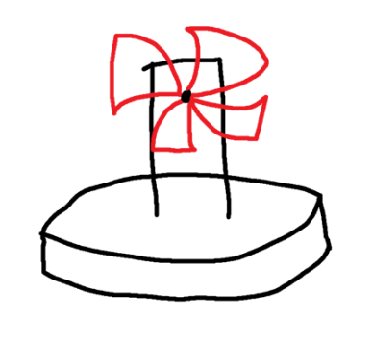

# Learning diary

## Week 22.3 – 28.3

* Formed our group and came up with the idea for our project.

## Week 29.3 – 4.4

* We finalized our concept design
* We decided on how to build the chassis and propeller, and what materials to use for them
  + 3d print the propeller
  + Laser cut plywood for the chassis.
* Wrote the introductory report
* Working code for Arduino in simulator (Uploaded to the project GitHub)
* Attended TA session and discussed about the 3d printing the propeller and laser cutting the chassis. The TA approved our concept.

## Week 5.4 – 11.4

* First draft with real Arduino Uno working with LED, problems with the given motor.

## Week 12.4 - 18.4

* Acquired a new motor and temperature sensor.
* The code works on the Arduino, but we haven't yet finished the full configuration

## Week 19.4 – 25.4

* Finished the 2d model for the chassis and 3d model of the propeller
* We wanted the design of the chassis to work differently than it does in the final version. We would have liked it to blow air in the direction of the components, but due to limitations of the flexibility of the power cable we opted to have it blow “backwards” compared to conventional fan design.
* 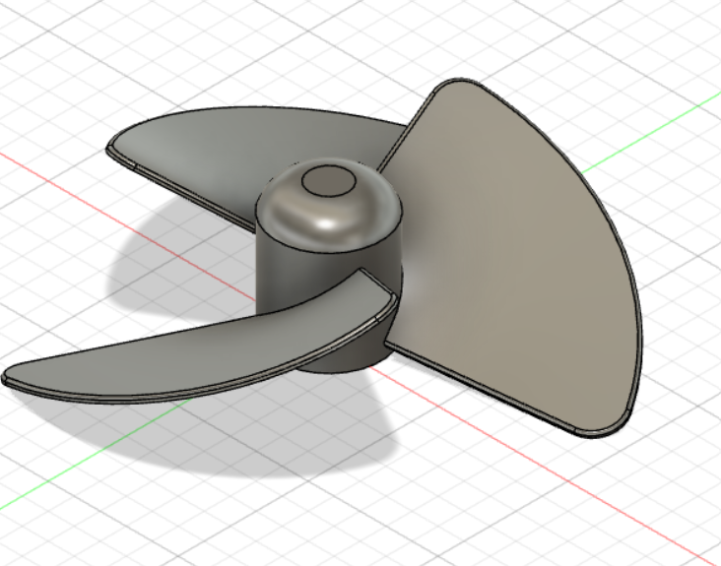
* 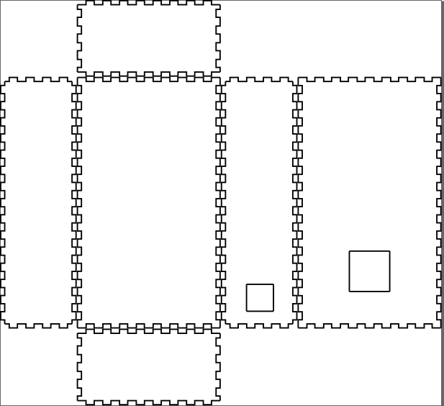
* 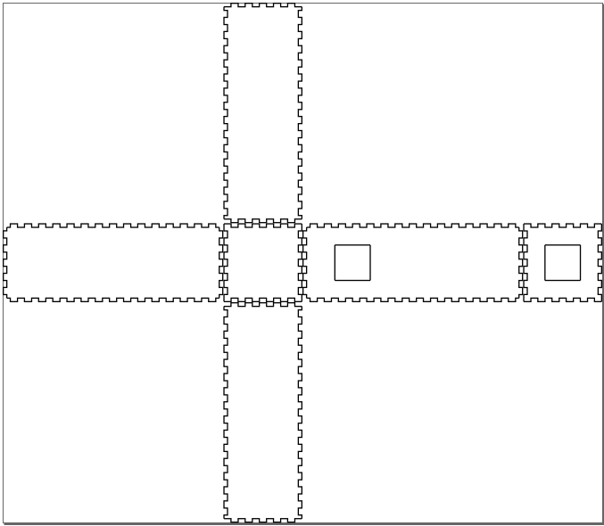

## Week 25.4 – 2.5

* We reserved times for the FabLab and went to produce the chassis and propeller
* Encountered a few problems with the design of the chassis. The holes were either in the wrong location or too small, but with small adjustments I produced the working chassis with relative ease.
* We assembled the chassis. It fit together well and was large enough contain the electronics.
* We had problems with getting the electronics working, specifically getting the motor running. We think this was because we had a IRLZ34N transistor which has a different pin layout to the PN2222, which was in the instruction set of the Moodle material. After consulting with the Teaching assistants and other students, we figured out the correct pin layout and managed to get it working.
* After getting the motor to spin, we encountered a new problem where we couldn’t control the motor in the way we wanted. The problem was that the motor couldn’t be stopped.